SYSTEM MANAGEMENT ADMINISTRATION
Project Plan
Project Title:
Autonomous Portable Dual Axis Solar Charging Station with Shadow Avoidance Mobility
I. Objectives
- Provide a robust platform for tracking, logging, and managing solar station telemetry.
- Achieve accurate sun-tracking using LDR (Light Dependent Resistor) sensor arrays.
- Provide real-time battery and panel voltage monitoring.
- Enable remote manual override via a mobile application.
- Ensure data integrity during offline periods via local storage synchronization.
II. Network Overview
The solar tracking system operates over a local wireless network, facilitating communication between the hardware edge devices and the central server. The ESP32 acts as the primary IoT gateway, connecting to the local Wi-Fi to transmit telemetry data and receive commands. A Laravel-based RESTful API backend manages incoming data, storing it in a PostgreSQL database (Supabase), and serves this data to both the React Native mobile application and web dashboard.
III. Network Components
Hardware
- ESP32 Microcontroller: Acts as the main IoT gateway for Wi-Fi communication and logic processing.
- Arduino Uno: Handles low-level sensor reading and precise servo motor control.
- LDR Sensors: Analog sensors for measuring light intensity to calculate optimal sun orientation.
- Servo Motors (MG996R): Provide physical actuation (vertical and horizontal) to adjust the solar panel position.
- Power Supply/Battery: Provides energy to the station and serves as a monitoring endpoint.
Software
- Laravel Framework: REST API backend to process requests and serve the dashboard.
- Supabase (PostgreSQL): Primary database for telemetry, logs, and system configuration.
- React Native (Expo): Cross-platform framework used for the Android mobile control application.
- Docker & Nginx: Used for containerized deployment of the web dashboard.
IV. Schedule
Tasks | Start Date | Duration | End Date
1. Planning/Design
1.1 Project Definition | 2/02/2026 | 5 | 2/06/2026
1.2 Finish Webpage | 2/09/2026 | 10 | 2/020/2026
1.3 Project Design: | 2/23/2026 | 5 | 2/27/2026
2. Coding
2.1 Phase 1: | 3/02/2026 | 10 | 3/13/2026
2.2 Phase 2 | 3/16/20263 | 15 | 4/03/2026
2.3 Additional Features | 4/06/2026 | 5 | 4/10/2026
3. Testing
3.1 Phase 1 Testing | 3/11/2026 | 7 | 3/19/2026
3.2 Phase 2 Testing: | 4/01/2026 | 7 | 4/09/2026
3.3 Final Testing: | 4/13/2026 | 10 | 4/24/2026
4. Documentation
4.1 User Guide | 4/20/2026 | 5 | 4/24/2026
4.2 Presentation | 4/27/2026 | 4 | 4/30/2026
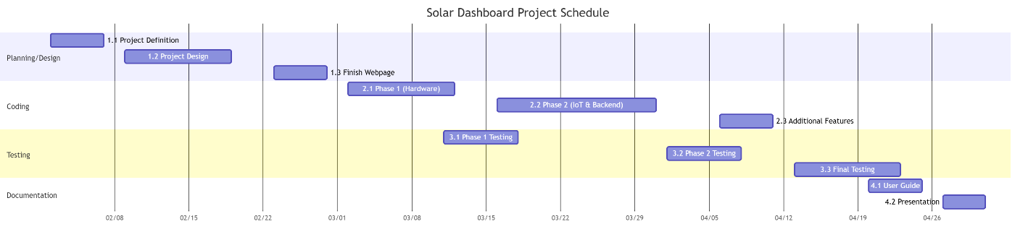

V. Use Case Diagram
Actors
- Project Owner
- System Users / Operators
Use Cases
- Monitor Live Dashboard
- Manual Override (Solar Controller)
- View Events and Logs
- Configure System Settings
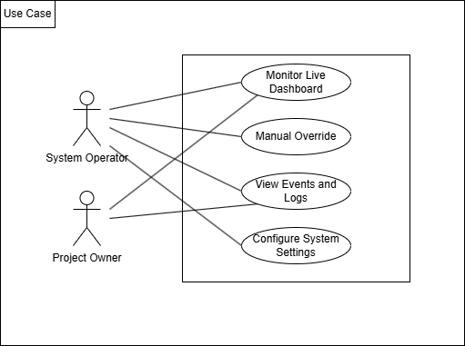

VI. Budgetary Management Plan
A. Hardware Cost Estimate

Item | Quantity | Unit Cost (PHP) | Total Cost (PHP)
ESP32 Development Board | 2 | 333 | 666
Arduino Uno | 4 | 840 | 3360
LDR Sensor Arrays | 6 | 44 | 264
MG996R Servo Motors (x2 | 2 | 383 | 766
Power Supply / Battery Units | 2 | 510 | 1020
Miscellaneous (Wires, Breadboards, Mounts) | 20 | _ | 2000
 |  | Total: | 8076
B. Software Cost Estimate
Item | Quantity | Unit Cost (PHP) | Total Cost (PHP)
Laravel Framework: Open Source |  | 0 | 0
React Native / Expo: Open Source |  | 0 | 0
Supabase (PostgreSQL): Free Tier |  | 0 | 0
IDE / Tooling (VS Code, Arduino IDE): Free | 1 | 1,100 | 1,100
 |  | Total: | 1,100

VII. Project Staffing (Development Phase)
A. Project Developer
The project is currently managed by a core development team handling full-stack implementation from hardware to UI. Core roles include: Project Manager, Firmware Engineer, Backend Developer, Mobile Developer, and Software Tester.

Name | Role | Responsibility
Rusel R. Portes | Mobile Developer | React Native Android application development and UI/UX design.
Rayla G. Lanaza | Project Manager | Strategy, documentation, monitoring product backlog, and user acceptance sign-off.
Efren S. Cabudbud | Software Tester | Quality assurance, hardware validation, and test case script execution.
Liza Mae Sugala | Backend Developer | Laravel REST API development, database architecture, and server management.
Jay Mark Renos | Firmware Engineer | ESP32 and Arduino firmware development, sensor integration, and motor logic.

VIII. Conclusion / Reflection.
The Autonomous Solar Tracking Station project represents a comprehensive integration of hardware engineering, IoT communication, and modern web and mobile application development. By adhering to this Project Plan, the development team establishes a clear roadmap from initial design to final testing within the designated timeframe (February to April 2026). The scheduled milestones ensure that both the physical hardware and the digital infrastructure are developed in tandem, ultimately delivering a reliable, efficient, and user-friendly platform for sustainable energy management and autonomous solar tracking.
Members: Instructor:
Rusel R. Portes Aljohn Badayos
Rayla G. Lanaza
Efren S. Cabudbud
Liza Mae Sugala
Jay Mark Renos

